Assignment 8, The Vestibular System

Seqian Wang, In Collaboration with Sulantha Mathotaarachchi and Maxime Parent

# Semicircular canal mechanics versus afferent responses

For the code, please refer to aCode.m.

## Input and Output sinewaves

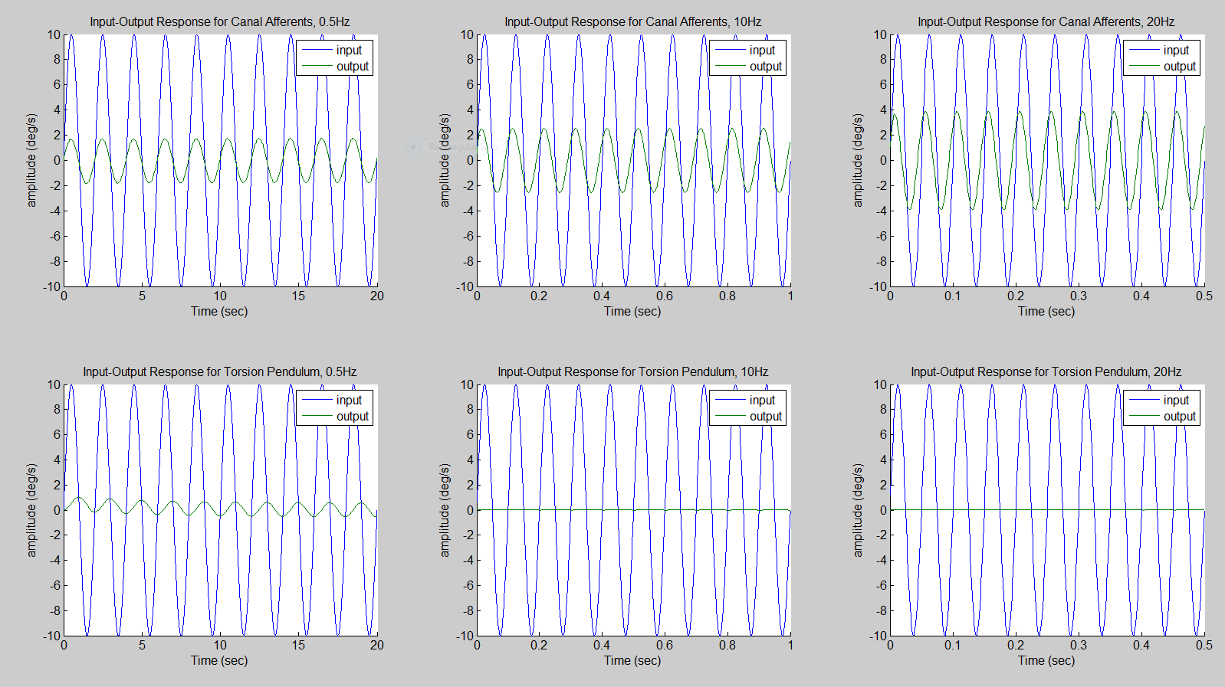

Figure : Input and output sinewaves for the Canal Afferents and Torsion Pendulum at different fundamental frequencies.

## Manually compute the input-output gain and phase shift (in degrees)

To measure the input-output gain, I divided the peak in the output by the peak in the input (measured manually). As for the phase shift, I measured the time difference and multiplied it by the fundamental frequency used (times 360).

|  |  |  |  |  |
| --- | --- | --- | --- | --- |
| **Observed** | Frequency | 0.5 Hz | 10 Hz | 20 Hz |
| Canal Afferents | Gain | 0.18 | 0.25 | 0.39 |
| Phase Shift | 30 | 36 | 50.4 |
| Torsion Pendulum | Gain | 0.10 | 0.0055 | 0.0027 |
| Phase Shift | -86.04 | -100.8 | -115.2 |

## Transfer Function and Bode Plots

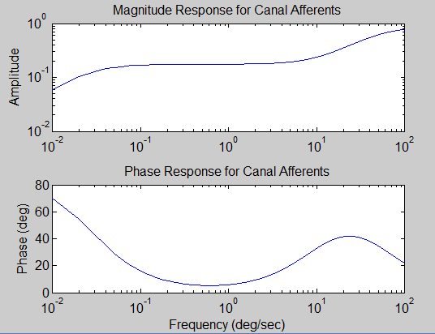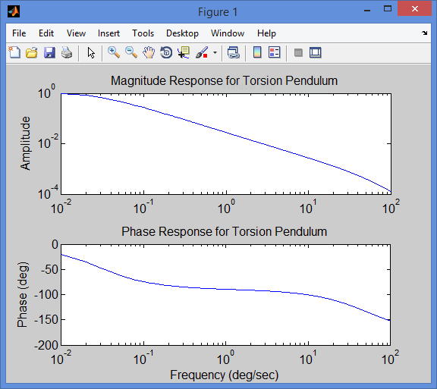

Figure : Bode plots for Canal Afferents and Torsion Pendulum.

For the gain, the canal afferents amplify the higher frequencies, whereas the torsion pendulum amplify the lower frequencies.

For the phase shift, canal afferents shift the response to the right, while the torsion pendulum shifts the response to the left. Additionally, canal afferents induce more shift with lower frequencies inputs, whereas the torsion pendulum is more responsible for the higher frequencies.

## Do the Bode plots predict well the gains and phases computed in #3?

|  |  |  |  |  |
| --- | --- | --- | --- | --- |
| **Expected** | Frequency | 0.5 Hz | 10 Hz | 20 Hz |
| Canal Afferents | Gain | 0.18 | 0.24 | 0.35 |
| Phase Shift | 29.4 | 32.7 | 41.5 |
| Torsion Pendulum | Gain | 0.10 | 0.003 | 0.0013 |
| Phase Shift | -60.87 | -100 | -110.7 |

The gains from the bode plots are similar to those manually measured. As for the phase shift, the values obtained are higher, but the trend between fundamental frequencies remain the same. The discrepancies may be due to human error (manual and imprecise measures).

## What is the benefit of using Matlab’s zpk command?

The Matlab’s zpk command provides us a mean to script the construction of a zero-pole gain model without having to rely on a Graphical User Interface or Simulink.

# A control system for the VOR

For the code, please refer to bCode.m

## Input and Output sinewaves

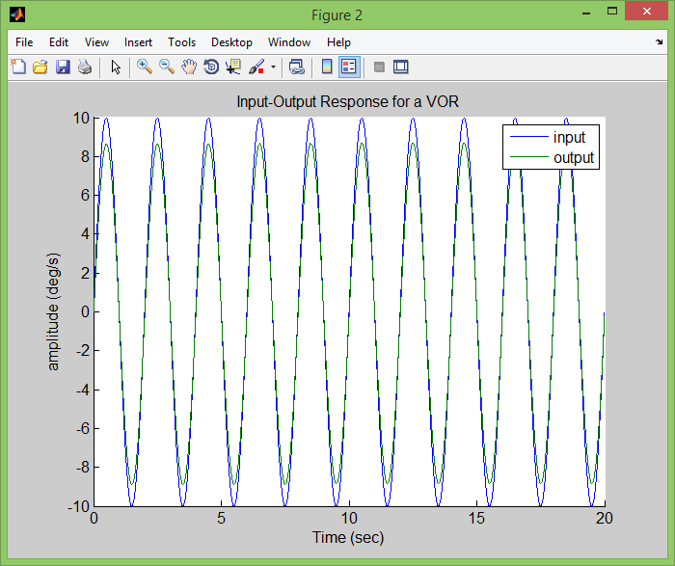

Figure : Input and output sinewaves for the VOR, 0.5 Hz sinewave input.

The output sinewave only has a slightly delay compared to its input. However, the amplitude of the output is not as great as the input, suggesting that the VOR cannot compensate for large head movements. This makes physiological sense, since we know the VOR only works within a certain angle of the fixation.

## Transfer Function and Bode Plots

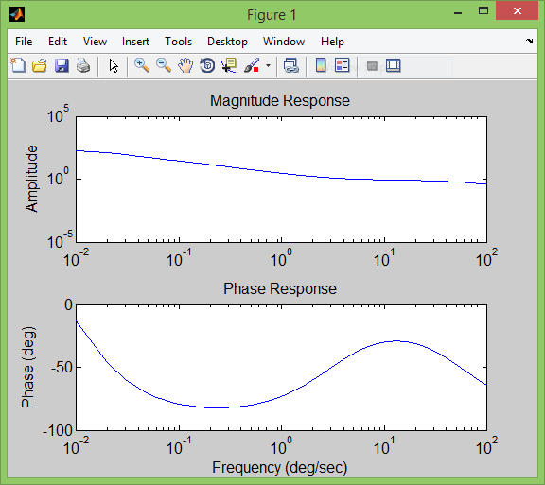

Figure : Bode Plots of the VOR circuit without delay

## Physiological delay effect

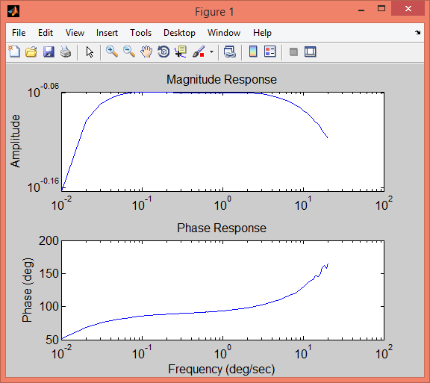

Figure 5: Bode Plots of the VOR circuit with a physiological delay of 0.007

The physiological delay seems to significantly change the behavior of the system. The most noticeable change is the increase in phase shift, especially at high input frequencies.

## Block that compensate for the physiological delay

The Canal Afferent transfer function has a high magnitude response, especially at higher frequencies (see below). Thus, this block is perhaps the one who compensates the most for the physiological delay found at higher frequencies.

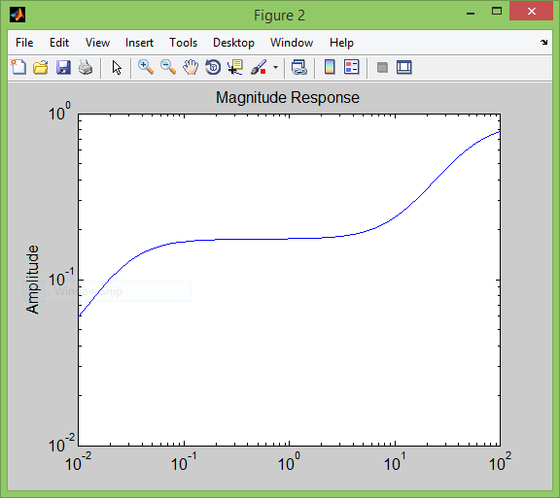

Figure : Magnitude Response for the Canal Afferent Transfer Function

## Time constants for vestibular afferents, the vestibular nuclei, and eye movement

The time constants can be found by determining the time for the decay to reach 63% of its peak. With this in mind, we measured it manually:

|  |  |  |
| --- | --- | --- |
| **Time constants (in seconds)** | $$τ_{1}$$ | $$τ_{2}$$ |
| After Vestibular Afferents | 0.00175 | 2.39 |
| After the Vestibular Nuclei | 0.0019 | 9.19 |
| After the Eye Movement |  | 9.24 |

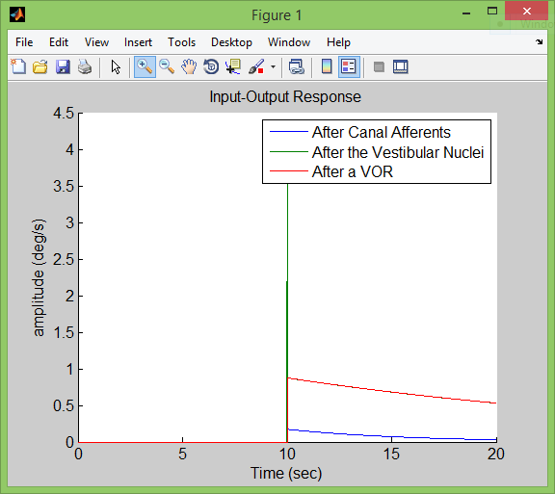

Figure 7: Output after different stages of the VOR, with a pulse input

In the figure above, which only shows the output response to a pulse generator, the response from the canal afferents is a lot smaller than the other two. In addition, the output after the vestibular nuclei overlap with the VOR function. The main difference is that the response from the VOR only have one time constant and does not have the overshoot as shown here.

# Mutual information and temporal coding in vestibular pathways

## Coefficient of Variance

$$CV=\frac{σ}{μ}=\frac{SD_{ISI}}{Avg_{ISI}}$$

|  |  |  |
| --- | --- | --- |
|  | Coefficient of Variance | Neuronal Firing |
| Afferent_model_1.mat | 0.2465 | Irregular |
| Afferent_model_2.mat | 0.0508 | Regular |

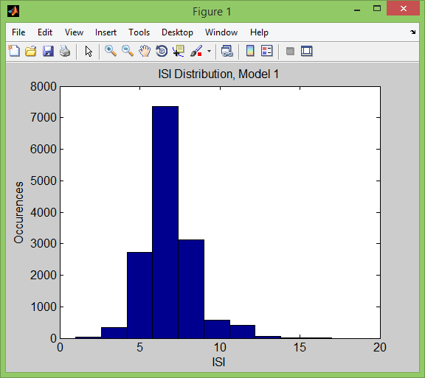 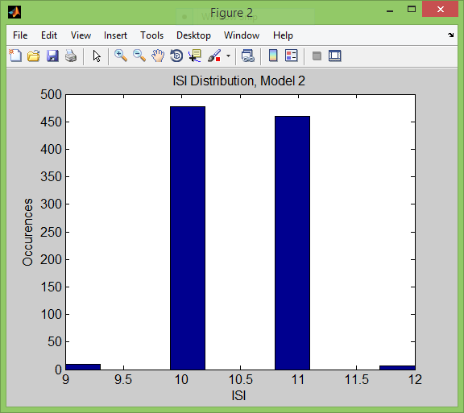

The coefficient of variance informs on the dispersion or variability of a dataset. The greater the coefficient of variance, the more variability there is. As shown in the ISI Distribution histograms, there is more variability in the first model (irregular), whereas most ISI falls either on 10 or 11 ms in the second model (regular).

## Response Gain

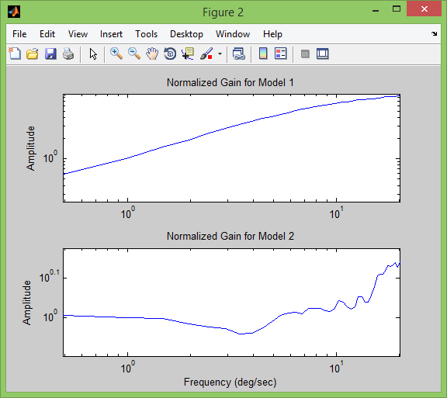

The figure above shows that the gain increases with frequency in model 1, whereas the gain remains fairly stable in model 2.

## Mutual Information Density

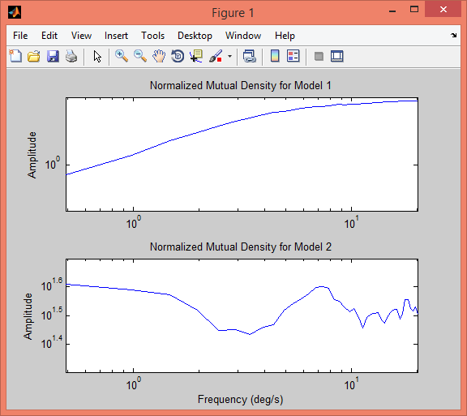

The mutual information density measures the variables’ mutual dependence (in this case, stimulus and spike train). The resulting figure is fairly similar to the gain bode plots. The gain and mutual density remains fairly constant across frequencies in Model 2, whereas it increases as frequency gets higher in Model 1.